**[DAILY NEWS](https://app.eikaiwa.dmm.com/daily-news)**

[**All**](https://app.eikaiwa.dmm.com/daily-news/search)

**Category**

**翻訳を表示**

**Man Records History of Humanity in Stone**

**2018年10月1日**

Proficient

9

[Culture & Entertainment](https://app.eikaiwa.dmm.com/daily-news/category/Culture%20&%20Entertainment)

[World](https://app.eikaiwa.dmm.com/daily-news/category/World)

[**Exercise 1**](https://app.eikaiwa.dmm.com/daily-news/article/man-records-history-of-humanity-in-stone/XxemlLo2Eei-0w9DYcmzPg#exercise-1)

**Vocabulary**ボキャブラリー

**invasion**

名詞

侵入、侵略

**ɪnˈveɪʒən**

the act of trying to take control of another country by force

The Battle of the Pyramids took place during the French **invasion** of Egypt.

ピラミッドの戦いは、フランスによるエジプトの侵略中に起きた。

**engrave**

動詞

（金属や石などに）彫る、刻む

**ɪnˈɡreɪv**

to cut something into a hard surface, such as stone or metal

She had her name **engraved** on the back of the watch.

彼女は、腕時計の後ろに自分の名前を彫ってもらった。

**collective**

形容詞

集合的な、共同の

**kəˈlɛktɪv**

done or shared by all members of a particular group

They are making a **collective** decision.

彼らは集団としての決定を下そうとしている。

**successor**

名詞

取って代わるもの、後継者

**səkˈsɛsər**

a person or thing that comes after and takes the place of someone or something else

I was asked to nominate my own **successor**.

私は自分の後継者を指名するように言われた。

**optimist**

名詞

楽天家、楽観主義者

**ˈɑːptɪmɪst**

a person who tends to be hopeful and positive

Ever the **optimist**, he insisted it wouldn't rain.

彼は大変な楽観主義者で、雨は降らないだろうと言い張った。

**self-directed**

形容詞

自分に向けた、自発的な

**self dɪˈrektɪd**

done or controlled by oneself

My degree involved a lot of **self-directed** study.

私の学位には、自発的な学習が多く含まれていた。

[**Exercise 2**](https://app.eikaiwa.dmm.com/daily-news/article/man-records-history-of-humanity-in-stone/XxemlLo2Eei-0w9DYcmzPg#exercise-2)

**Article**ニュース記事

**Man Records History of Humanity in Stone**

At 90 years old, Jacques-Andre Istel understands the power of history. He was 11 in 1940, when he came from France to the US to avoid the Nazi invasion. He’s been called “the father of American skydiving,” after founding the first sport parachuting school in the US. He even owns a piece of the Eiffel Tower, which he keeps on his front lawn.

But Istel’s most lasting achievement will surely be the Museum of History in Granite, in Felicity, California. The museum was founded in 2002, with the following mission: “to engrave in granite highlights of the collective memory of humanity.”

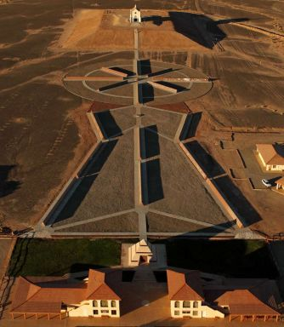

The Museum of History in Granite

The outdoor museum is made up of monuments constructed from concrete, steel, and granite, which are designed to last 4,000 years. Each monument is about 30 meters long and holds 60 panels of Missouri red granite, each weighing over 200 kilograms. Text and pictures are hand-engraved by experts onto the granite panels.

The largest of the exhibits is the “History of Humanity.” Istel has summarized all of human history on 416 panels, which are still being engraved. Asked when the project might be finished, Istel replies, “The last hundred or so may have to be engraved by successors. [But] as an optimist, I hope to complete the work.”

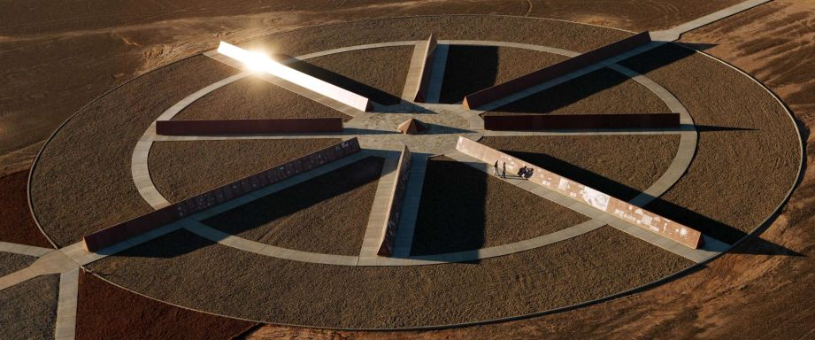

The "History of Humanity"

At the center of the “History of Humanity” sits the “Felicity Stone,” based on the Rosetta Stone which allowed ancient Egyptian text to be translated and understood. Each side contains the same message in a different language, part of which reads, “On behalf of the people of the world, this monument is designed as a key for visitors of the far distant future to understand our writings.”

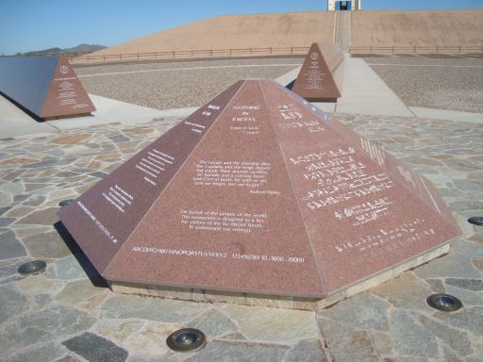

The "Felicity Stone"

When asked what someone from the distant future might think of humanity after visiting his museum, Istel simply says, “Your guess is as good as mine.”

Whether or not it lasts 4,000 years, the museum is popular today. It’s even been nominated as a UNESCO World Heritage site. Istel hopes it will make people want to keep learning about the world, saying, “The purest form of education may be a self-directed search for knowledge.”

[**Exercise 3**](https://app.eikaiwa.dmm.com/daily-news/article/man-records-history-of-humanity-in-stone/XxemlLo2Eei-0w9DYcmzPg#exercise-3)

**Discussion**議論

1.

What are your thoughts on the Museum of History in Granite?

2.

Would you like to visit Istel's museum? Why? Why not?

3.

What period of history are you most interested in? Why?

4.

What do you imagine people will think of our society 4,000 years from now? Please explain your answer.

5.

What do you make of the claim that the best form of education is "a self-directed search for knowledge"?

[**Exercise 4**](https://app.eikaiwa.dmm.com/daily-news/article/man-records-history-of-humanity-in-stone/XxemlLo2Eei-0w9DYcmzPg#exercise-4)

**Further Discussion**一歩踏み込んだ議論

1.

If you could meet any person from history, who would you choose and why?

2.

If you could travel back in time, what historical events would you like to see? Please explain your answer.

3.

Would you rather travel back in time or into the distant future? Why?

4.

What historical period do you want to learn more about? Why?

5.

What historical buildings, objects, or sites do you want to see someday? Please explain your answer.

[**Exercise 5**](https://app.eikaiwa.dmm.com/daily-news/article/man-records-history-of-humanity-in-stone/XxemlLo2Eei-0w9DYcmzPg#exercise-5)

**Quotes**引用文

1.

*A people without the knowledge of their past history, origin and culture is like a tree without roots.* - Marcus Garvey. Do you agree? Why? Why not?

2.

*History doesn't repeat itself but it often rhymes.* - Mark Twain. What do you make of this statement?

**Source**

This lesson is based on an original news article by H.J. Meech.   
Image Credits: [Museum of History in Granite](http://www.historyingranite.org/), Felicity, CA, USA.

シェア

Related Articles

**[Scientists Design Chips to Act Like Human Organs](https://app.eikaiwa.dmm.com/daily-news/article/scientists-design-chips-to-act-like-human-organs/d2P87KZcEeaahMdGoyNzQQ)**

[3年前](https://app.eikaiwa.dmm.com/daily-news/article/scientists-design-chips-to-act-like-human-organs/d2P87KZcEeaahMdGoyNzQQ)

[Advanced](https://app.eikaiwa.dmm.com/daily-news/article/scientists-design-chips-to-act-like-human-organs/d2P87KZcEeaahMdGoyNzQQ)

[8](https://app.eikaiwa.dmm.com/daily-news/article/scientists-design-chips-to-act-like-human-organs/d2P87KZcEeaahMdGoyNzQQ)

[Science & Technology](https://app.eikaiwa.dmm.com/daily-news/article/scientists-design-chips-to-act-like-human-organs/d2P87KZcEeaahMdGoyNzQQ)

**[80 Years Later, Millions Still Escape from Alcatraz](https://app.eikaiwa.dmm.com/daily-news/article/80-years-later-millions-still-escape-from-alcatraz/LexBBrWXEeal9bfiZ-eAVQ)**

[3年前](https://app.eikaiwa.dmm.com/daily-news/article/80-years-later-millions-still-escape-from-alcatraz/LexBBrWXEeal9bfiZ-eAVQ)

[Intermediate](https://app.eikaiwa.dmm.com/daily-news/article/80-years-later-millions-still-escape-from-alcatraz/LexBBrWXEeal9bfiZ-eAVQ)

[6](https://app.eikaiwa.dmm.com/daily-news/article/80-years-later-millions-still-escape-from-alcatraz/LexBBrWXEeal9bfiZ-eAVQ)

[USA & Americas](https://app.eikaiwa.dmm.com/daily-news/article/80-years-later-millions-still-escape-from-alcatraz/LexBBrWXEeal9bfiZ-eAVQ)

**[Forgotten Speeches Come Alive on YouTube](https://app.eikaiwa.dmm.com/daily-news/article/forgotten-speeches-come-alive-on-youtube/R4K9drWbEeaGmWdIo94S7Q)**

[3年前](https://app.eikaiwa.dmm.com/daily-news/article/forgotten-speeches-come-alive-on-youtube/R4K9drWbEeaGmWdIo94S7Q)

[Intermediate](https://app.eikaiwa.dmm.com/daily-news/article/forgotten-speeches-come-alive-on-youtube/R4K9drWbEeaGmWdIo94S7Q)

[6](https://app.eikaiwa.dmm.com/daily-news/article/forgotten-speeches-come-alive-on-youtube/R4K9drWbEeaGmWdIo94S7Q)

[Culture & Entertainment](https://app.eikaiwa.dmm.com/daily-news/article/forgotten-speeches-come-alive-on-youtube/R4K9drWbEeaGmWdIo94S7Q)

**Presented by**

DAILY NEWSは、DMM英会話が提供する学習教材です。無料で全てのコンテンツをご利用いただけますが、DMM英会話会員になると、これらの教材に精通したプロの講師と学習することができます。毎日話せるオンライン英会話 - **[DMM英会話](https://eikaiwa.dmm.com/)**

* [Science & Technology](https://app.eikaiwa.dmm.com/daily-news/category/Science%20&%20Technology)
* [Culture & Entertainment](https://app.eikaiwa.dmm.com/daily-news/category/Culture%20&%20Entertainment)
* [Economy & Business](https://app.eikaiwa.dmm.com/daily-news/category/Economy%20&%20Business)
* [Health](https://app.eikaiwa.dmm.com/daily-news/category/Health)
* [Language & Education](https://app.eikaiwa.dmm.com/daily-news/category/Language%20&%20Education)
* [World](https://app.eikaiwa.dmm.com/daily-news/category/World)
* [Asia](https://app.eikaiwa.dmm.com/daily-news/category/Asia)
* [USA & Americas](https://app.eikaiwa.dmm.com/daily-news/category/USA%20&%20Americas)
* [Europe](https://app.eikaiwa.dmm.com/daily-news/category/Europe)
* [Middle East & Africa](https://app.eikaiwa.dmm.com/daily-news/category/Middle%20East%20&%20Africa)
* [DMM英会話について](https://eikaiwa.dmm.com/guide/)
* [レッスン教材](https://eikaiwa.dmm.com/material/)
* [予約・講師検索](https://eikaiwa.dmm.com/list/)
* [よくある質問](http://help.dmm.com/-/list/=/mid=291/)
* [お問い合わせ](https://www.dmm.com/help/support/index.html)

Copyright © since 1998. DMM All Rights Reserved.

<https://app.eikaiwa.dmm.com/daily-news/article/man-records-history-of-humanity-in-stone/XxemlLo2Eei-0w9DYcmzPg>